Gender and Medieval Studies conference
Swansea University, 6th – 8th January 2020

Gender, Science, and the ‘Natural’ World
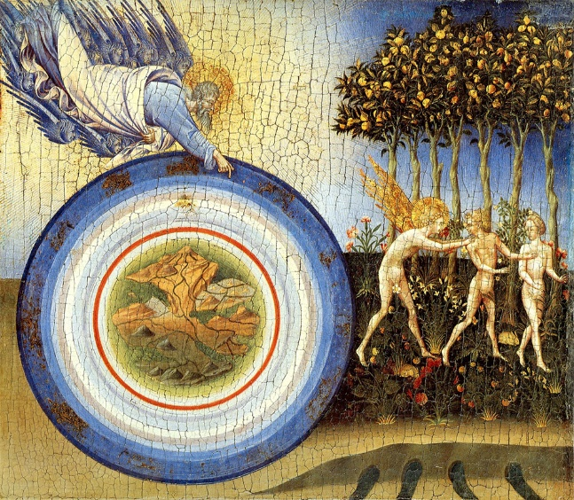

Two contrasting interpretations of human creation – the Aristotelian conception of the ‘natural’ default of life as male, and Hildegard of Bingen’s conception of life as a feminized process of natality and viriditatas (‘greening’) – subscribe in different ways to an ancient and medieval worldview that prioritises a God-given schematic order with the human at its centre. For Aristotle (d. 322 BCE), however, ‘Females are weaker and colder in their nature (than males) and we should look upon the female state as being as it were a deformity’ (On the Generation of Animals 4:3); whereas for Hildegard (d. 1179) the natural world presents as a dynamic, God-given revelation of natality in its greenness, unfolding and flourishing: ‘By the secret design of the Supernatural Creator . . . the infant in the maternal womb receives a spirit, and shows by the movements of its body that it lives, just as the earth opens and brings forth the flowers of its use when the dew falls on it’ (Scivias, I.iv). This conference will interrogate such gendered configurations of the ‘natural’ world in the medieval imaginary and the influence of scientific and medical ideas upon understandings of the universe.
We seek papers engaging with such ideas from a range of disciplines and intersectional approaches, encompassing, for example, history, literature, medicine, theology, science, politics, archaeology, medical humanities, music, and art. The conference will explore the diverse ways in which medieval writers, artists and other thinkers respond to apparently hegemonic schemas of ‘science’ and ‘nature’ during the Middle Ages. How is ‘nature’ conceptualised? In what ways are scientific and philosophical systems upheld and subverted? What occurs when such models are inflected by gender, race, differently-abled bodies or queered? What might be figured as unnatural, and how is such a notion connected to gender, power and desire? How is the ‘natural’ world conducive or inconducive to bodily or spiritual health? And how do human and non-human bodies align or jar within this schema? Recently, Donna Haraway has argued that the Greek idea of the Chthulucene – a ‘timeplace’ of the now and new beginnings, but which also imbricates remembrance and the what-might-yet-be – offers understanding of a diachronic entanglement of all earthly existents as deeply connected ‘mixed assemblages’ (‘Making Kin’, 2015). In examining the order and disorder of the medieval world from a range of intersectional perspectives, like Harraway, we will ask what is at stake for our understanding of the earth, the human, in the then and the now.

Proposals for papers might engage with, but are not limited to:
- Scientific understandings of the natural world
- Scientific explanations of the gendered human body
- The relationship between the human and non-human
- Semioses of the human position in the medieval universe and the ways that people self-conceptualised
- Order / disorder / queerness / monstrosity
- Medieval medicine and its connection to the ‘natural’ world
- The music of the spheres
- The medieval garden and its heterotopic spaces
- Discourses of flourishing and atrophy
- Theologies of ‘nature’ and the ‘natural’
- The interrelation of medicine and religion

We are now calling for proposals of 300 words, from scholars at any stage of study or career, for:
- Standard 20-minute papers;
- Position-paper sessions (90-minutes) with up to 7 participants;
- Roundtable sessions (90-minutes) with up to 5 participants;
- Postgraduate research posters for a competition (the winner will receive free GMS registration for the 2021 conference. The poster will be published on the website)

Contributions engaging with a range of theoretical approaches are particularly welcome.

Abstracts should be sent to Laura Kalas Williams (l.e.williams@swansea.ac.uk) by 31st July 2019.

Visit the Gender and Medieval Studies website at http://medievalgender.co.uk/ and find us on Twitter @medievalgender.

